
A project report on
RIDERS, RIVALS AND RUSH HOURS:
A GAME-THEORETIC ANALYSIS OF INCENTIVE AND CAPACITY
COMPETITION BETWEEN FOOD DELIVERY PLATFORMS
Submitted in partial fulfilment for the award of the degree of
M.Tech [Integrated]
Computer Science and Engineering in Collaboration with Virtusa &
with Specialization in Data Science
by
DARA KARTHIKEYA – 23MIC0008
SRI VARSHINI SOMINENI – 23MID0455
GUNDLURU MANVITHA REDDY – 23MID0279
LIKITHA REDDY K – 23MID0332
SCHOOL OF COMPUTER SCIENCE AND ENGINEERING
October 2026

1. ABSTRACT
Riders, Rivals and Rush Hours is a game-theoretic analysis and interactive web application that studies how two competing food-delivery platforms, Platform A and Platform B (motivated by Swiggy and Zomato), make strategic decisions during lunch and dinner peaks. Both platforms serve the same customers and draw riders from one shared pool of multi-homing riders. When one platform raises its rider incentive, riders move away from the rival, so each platform's delivery delay, completed orders and costs depend on the other platform's choices.
The project builds a single shared market environment that every model uses: a logit model of rider supply, a capacity-and-queueing model of delivery delay, a delay-sensitive logit model of customer demand solved as a demand–delay fixed point, and platform profit and welfare measures. On this common environment the platforms compete in nine different ways: Cournot capacity competition, Bertrand competition on rider incentives (including the homogeneous Bertrand paradox) and on delivery fees, Stackelberg leadership, a two-stage capacity-then-fee game, a discrete strategic-form game, a repeated game, a Bayesian game with private demand information, and social-planner and collusion benchmarks. Every equilibrium is verified numerically by checking that no platform can gain from a unilateral deviation.
The application is developed using React, Vite and TypeScript for the frontend and FastAPI with Python, NumPy and SciPy for the backend. An agent-based city simulation of a three-hour peak with 500 rider agents, run over 20 Monte Carlo seeds, is used to validate the analytical delay function. Results are presented through eleven interactive pages with charts, payoff matrices, game trees and an animated city map.
The main finding is that incentive wars mainly transfer surplus from platforms to riders. At extreme demand, incentive competition raises incentive spending by about ₹28,400 per hour compared with an incentive cartel, but reduces average delay by only 2.8 minutes. Moving first helps a platform that commits to capacity, while a platform that commits to an incentive is out-earned by its follower. Tacit cooperation is hardest to sustain at peak demand, where the critical discount factor rises from 0.51 to 0.71. The project demonstrates how core game-theory concepts can be combined in one consistent, verifiable and visual analysis of a real platform market.

2. INTRODUCTION

2.1 Introduction
Online food-delivery platforms operate two-sided markets. On one side, customers place orders and pay a delivery fee; on the other, independent riders decide which platform to work for based on the incentive paid per delivery. In Indian cities, the two leading platforms compete for the same customers and, crucially, for the same riders, many of whom keep both apps installed and switch between them (multi-homing).
During peak hours this competition becomes strategic. If Platform A raises its per-order incentive, riders shift from Platform B to Platform A. Platform B then has fewer riders, longer delivery times and fewer orders, which pressures it to raise its own incentive. Each platform's best decision therefore depends on what its rival does. Such interdependence cannot be analysed with ordinary single-firm optimisation; it requires game theory.
Riders, Rivals and Rush Hours models this situation formally. A single market environment describes how riders, customers, capacity and delay interact. On top of it, the project implements the main game-theoretic structures studied in the course: simultaneous-move games in quantities and prices, sequential games solved by backward induction, discrete strategic-form games with dominance and mixed strategies, repeated games with trigger strategies, and games of incomplete information. All models use exactly the same environment, so differences in outcomes come only from the strategic variable and the timing of moves.
The frontend is developed using React and Vite and provides eleven interactive pages. The backend uses FastAPI and Python to solve the models, verify every equilibrium and run an agent-based simulation of a city during a dinner rush. The project is intended as an analytical and educational platform; its results depend on the stated parameters and assumptions, which are illustrative rather than estimated from company data.

2.2 Objectives of the Project
The main objective of the project is to analyse incentive and capacity competition between two food-delivery platforms using game theory, and to present the analysis through an interactive web application. The specific objectives are:
- To build one shared market environment (rider supply, capacity, delay, customer demand, profit and welfare) that every game model uses, so that comparisons are valid.
- To model and solve simultaneous competition in capacity (Cournot), rider incentives and delivery fees (Bertrand), including the homogeneous Bertrand paradox.
- To model sequential competition (Stackelberg and a two-stage capacity-then-fee game) and solve it by backward induction, measuring the first-mover advantage.
- To analyse a discrete strategic-form version of the incentive game using best responses, iterated elimination of dominated strategies, mixed-strategy equilibria, maxmin strategies and Prisoner's Dilemma detection.
- To study whether platforms can sustain low incentives in a repeated game, by computing the critical discount factor and simulating a strategy tournament with imperfect observability.
- To model incomplete information about demand as a Bayesian game and compute type-contingent equilibrium strategies.
- To compare all structures against a social-planner benchmark using efficiency and the price of anarchy, across four demand scenarios.
- To validate the analytical delay function with an agent-based city simulation and Monte Carlo confidence intervals.
- To verify every equilibrium numerically and present all results through a clear, interactive dashboard with exportable charts and tables.

3. PROBLEM STATEMENT AND EXISTING SYSTEM

3.1 Problem Statement
During lunch and dinner peaks, competing delivery platforms (Platform A and Platform B, motivated by Swiggy and Zomato) serve the same customers and draw on an overlapping pool of multi-homing riders. When one platform raises rider incentives, riders shift away from the rival, so each platform's delays, completed orders and costs depend on the other's choices. Platforms that optimise in isolation fall into costly incentive wars that raise expenditure without proportionally reducing delays.
The problem addressed by this project is to model these decisions as strategic games and to compare the outcomes under different competitive structures and demand levels. The project must answer whether incentive competition actually improves delivery times or mainly transfers money to riders, when it helps a platform to move first, how patient platforms must be to avoid an incentive war, how private demand information changes decisions, and how far each competitive outcome is from what is best for society.

3.2 Overview of the Existing System
In practice, platforms set rider incentives and fees using internal rules, demand forecasts and surge-pricing systems that optimise each platform's own objective. These systems treat the rival's behaviour as part of the environment rather than as a strategic response. Analyses that are publicly available usually examine one platform at a time, using operational dashboards or spreadsheets.
In the academic literature, two-sided platform competition, on-demand service platforms with congestion, capacity precommitment and repeated-game cooperation are each studied with their own specialised model. In teaching, game-theory concepts are usually illustrated with small abstract payoff matrices that are not linked to a concrete market. As a result, it is difficult to see how the same market behaves under different strategic structures.

3.3 Limitations of the Existing System
- Isolated optimisation: each platform optimises its own incentives without explicitly modelling the rival's best response, which leads to incentive wars.
- Fragmented models: Cournot, Bertrand, Stackelberg, repeated and Bayesian games are usually analysed with different, incompatible assumptions, so their results cannot be compared directly.
- No congestion feedback: simple textbook models ignore that more orders increase delivery delay, which in turn reduces demand.
- No verification: equilibria computed numerically are often not checked for profitable deviations.
- Limited welfare view: analyses focus on platform profit and ignore customers and riders, so the social cost of competition is not measured.
- No validation of assumptions: analytical delay formulas are rarely checked against a more detailed simulation.
- Poor accessibility: results are presented as static equations or tables, which makes it hard to explore how they change with demand or parameters.

3.4 Need for the Proposed System
The proposed system addresses these limitations through the following features:
- One shared environment: every game model is solved on the same market primitives, so differences come only from strategy and timing.
- Strategic modelling: best responses of both platforms are modelled explicitly in simultaneous, sequential, repeated and incomplete-information settings.
- Congestion feedback: demand and delay are solved jointly as a fixed point.
- Verified equilibria: every equilibrium is checked for profitable unilateral deviations on a fine grid.
- Welfare benchmark: a social planner and a collusion benchmark measure efficiency and the price of anarchy.
- Validation: an agent-based simulation with Monte Carlo confidence intervals tests the analytical delay function.
- Interactive presentation: eleven pages with sliders, charts, payoff matrices, game trees, an animated city and PNG/CSV export.

4. LITERATURE SURVEY

4.1 Literature Survey Table
S. No. | Author(s) / Year | Paper Title | Methodology | Key Findings
1 | Rochet and Tirole (2003) | Platform Competition in Two-Sided Markets | Theoretical model of platforms setting prices to two user groups linked by cross-side network effects. | The structure of prices across the two sides, not only their level, determines platform outcomes; multi-homing affects competition.
2 | Armstrong (2006) | Competition in Two-Sided Markets | Models of monopoly platforms, competing platforms with single-homing, and competitive bottlenecks. | When one side multi-homes, platforms compete hard for the single-homing side; cross-group externalities shape prices.
3 | Kreps and Scheinkman (1983) | Quantity Precommitment and Bertrand Competition Yield Cournot Outcomes | Two-stage game: firms choose capacities, then compete in prices; solved for the subgame-perfect equilibrium. | Capacity precommitment followed by price competition reproduces the Cournot outcome.
4 | Axelrod (1984) | The Evolution of Cooperation | Computer tournaments of the iterated Prisoner's Dilemma with strategies submitted by researchers. | Tit-for-Tat performed best; nice, retaliatory and forgiving strategies sustain cooperation.
5 | Cachon, Daniels and Lobel (2017) | The Role of Surge Pricing on a Service Platform with Self-Scheduling Capacity | Model of a service platform whose independent providers decide when to work; compares pricing and wage contracts. | Dynamic (surge) pricing can make the platform, providers and customers better off than fixed contracts.
6 | Taylor (2018) | On-Demand Service Platforms | Queueing model with delay-sensitive customers and independent agents who choose whether to work. | Congestion and agent independence change the platform's optimal price and wage.
7 | Bai, So, Tang, Chen and Wang (2019) | Coordinating Supply and Demand on an On-Demand Service Platform with Impatient Customers | Queueing model with earnings-sensitive providers and waiting-sensitive customers; optimal price, wage and commission. | Price and wage should respond to demand; simple commission contracts can perform close to optimal.
8 | Bernstein, DeCroix and Keskin (2021) | Competition Between Two-Sided Platforms Under Demand and Supply Congestion Effects | Game-theoretic model of competing platforms with congestion on both sides and provider multi-homing. | Provider multi-homing and congestion materially change equilibrium prices, wages and platform profits.

4.2 Research Gap
The literature provides strong foundations for this project. Two-sided market theory explains how platforms set prices for both sides; on-demand platform models explain how congestion and independent providers affect prices and wages; capacity-precommitment and repeated-game results explain when competition is softened or cooperation is sustained.
However, these topics are usually studied separately, each with its own model and assumptions. A Cournot result from one paper cannot be compared directly with a Bertrand or repeated-game result from another, because the underlying demand, supply and congestion assumptions differ. Most models also focus on a single platform or a single competitive structure at a time, and few studies check numerically computed equilibria or validate their congestion functions.
There is therefore a need for one consistent framework in which the same delivery market, with the same multi-homing rider pool, congestion and customers, can be analysed under every major game-theoretic structure, and the outcomes compared side by side across demand levels.
Riders, Rivals and Rush Hours addresses this gap. It solves nine competitive structures on one shared market environment, verifies every equilibrium, compares all outcomes against a social-planner benchmark, validates the delay model with an agent-based simulation, and makes the whole analysis explorable through an interactive web application.

5. PROPOSED SYSTEM AND SYSTEM ARCHITECTURE

5.1 Overview of the Proposed System
Riders, Rivals and Rush Hours is a web-based analysis system that integrates a game-theory engine, an agent-based simulation and an interactive dashboard. The user selects a competitive structure and a demand scenario, adjusts market parameters, and the system computes and displays the resulting equilibrium together with delays, orders, profits, incentive spending and welfare.
The application follows a frontend–backend architecture. The frontend is developed using React, Vite, TypeScript and Tailwind CSS. The backend is developed in Python with FastAPI, and all model mathematics lives in the backend engine; the frontend only requests results and visualises them. This separation keeps the analysis consistent and testable.
Four demand scenarios are studied in every model: Low (600 potential orders per hour), Medium (1,000), Peak (1,500) and Extreme (2,000). All parameters are stored in one configuration file and can be changed from the interface, after which every page re-solves on the new parameters.

5.2 System Architecture
The architecture consists of the following layers, shown in Figure 5.1.
1. Frontend Layer: The frontend is developed using React 18, Vite and TypeScript with Tailwind CSS. It provides eleven pages: Overview, Model Playground, Model Comparison, Strategic Form Lab, Leader–Follower, Repeated Game Lab, Incomplete Information, City Simulation, Sensitivity Analysis, Methodology and Insights. Charts are drawn with Recharts, equations with KaTeX and the city with an HTML canvas. Every chart and table can be exported as PNG or CSV.
2. Backend API Layer: The backend uses FastAPI and Pydantic. It exposes REST endpoints such as /api/solve/{model}, /api/compare, /api/matrix-game, /api/repeated, /api/bayesian, /api/simulate, /api/sensitivity, /api/insights and /api/export. It validates inputs, merges parameter overrides with the defaults, caches results in memory and pre-computes the default results in the background.
3. Game-Theory Engine: The engine contains the shared MarketEnvironment, generic solvers (global best response, best-response iteration, Stackelberg solver and deviation checks) and one module per game model: Cournot, Bertrand, Stackelberg, two-stage, planner and collusion, matrix game, repeated game and Bayesian game.
4. Simulation Layer: An agent-based simulation of a 20 × 20 km city with 40 restaurants and 500 rider agents reproduces a three-hour dinner peak minute by minute. It is repeated over 20 random seeds to obtain confidence intervals and is compared with the analytical delay function.
5. Configuration Layer: Every parameter (rider pool, incentives, delay, demand, simulation settings) is stored in one JSON file, config/defaults.json, which every model reads. Any value can be overridden per request.
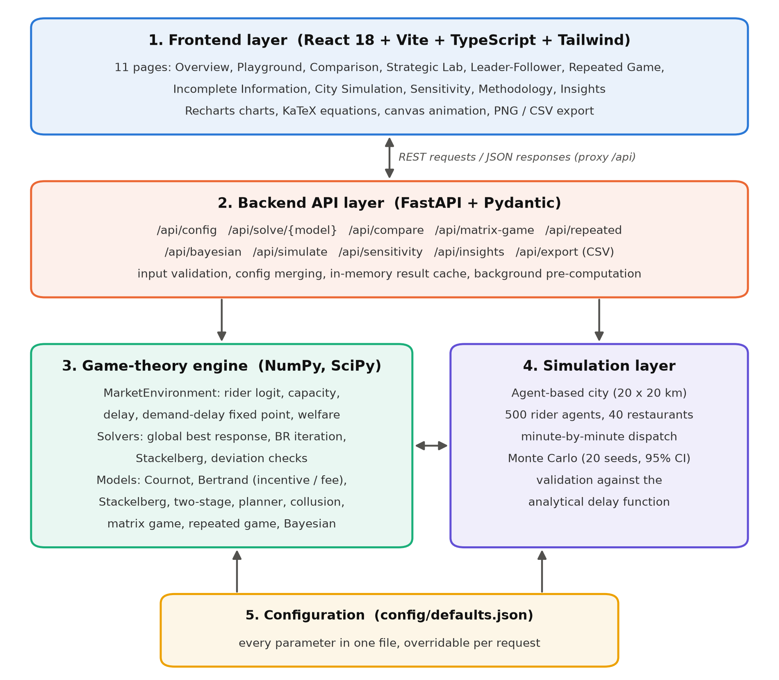
Figure 5.1: System Architecture of Riders, Rivals and Rush Hours

5.3 System Workflow
The workflow describes the sequence of operations when a user interacts with the application (Figure 5.2).
Step 1: User Interaction. The user opens a page, selects a model and a demand scenario, and adjusts sliders such as the number of riders or the rider sensitivity to pay.
Step 2: Request Submission. The frontend sends a POST request to the corresponding API endpoint with the selected scenario and any parameter changes.
Step 3: Backend Request Handling. FastAPI validates the request, merges the parameters with the defaults and returns a cached result immediately if the same request has been solved before.
Step 4: Solving. The engine solves the demand–delay fixed point and computes the equilibrium of the selected game, for example by best-response iteration or backward induction.
Step 5: Verification. Each equilibrium is checked by evaluating every platform's profit at 401 alternative strategies while the rival's strategy is held fixed.
Step 6: Response to the Frontend. The backend returns the equilibrium, metrics, best-response curves and verification result as JSON.
Step 7: Visualisation and Analysis. The interface displays metric cards, charts, payoff matrices, game trees or the city animation. The user can change inputs and the loop repeats.
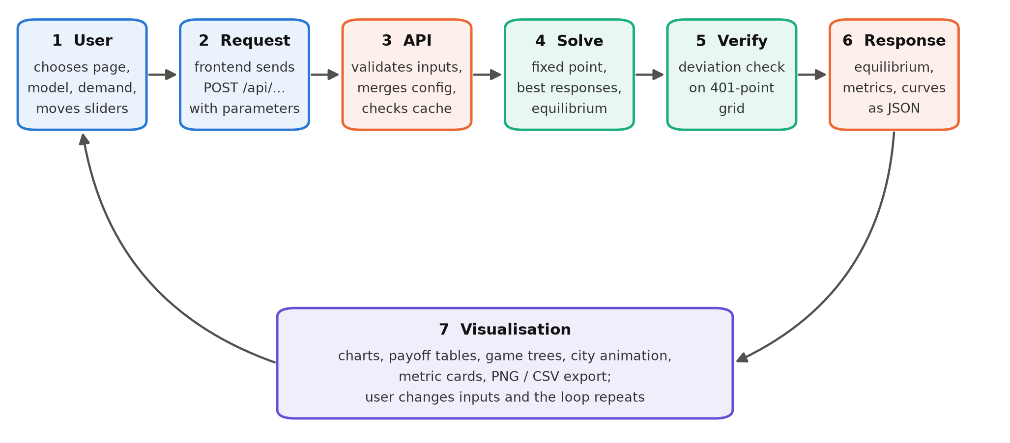
Figure 5.2: System Workflow of Riders, Rivals and Rush Hours

6. PROPOSED METHODOLOGY

6.1 Shared Market Environment
All models are evaluated on one market environment representing one peak hour in one city zone, with money measured in Indian rupees. Riders choose between Platform A, Platform B and an outside option (staying offline) according to a logit model:
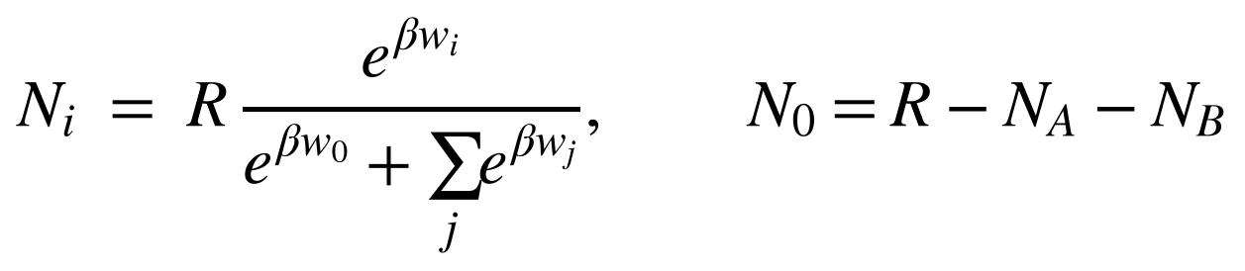
- R = 500 is the number of multi-homing riders and w_{i} is the incentive paid by platform i per order.
- w0 = ₹25 is the riders' reservation incentive and β = 0.15 measures how strongly riders respond to pay.
When a platform chooses its number of riders instead of its incentive, the same supply curve is inverted to give the incentive it must pay:
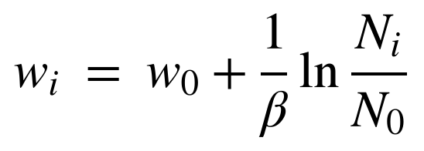
Each rider completes about k = 2.2 deliveries per hour, so the capacity and utilisation of platform i are:
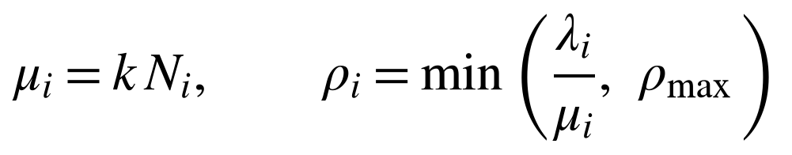
Delivery delay grows with utilisation following a queueing-based formula, with base delay d0 = 28 minutes and congestion scale s = 6 minutes:
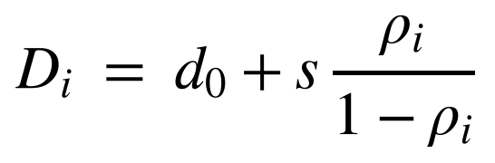
Customers choose Platform A, Platform B or not ordering using a logit model that depends on the delivery fee and the delay, where Λ is the potential order flow of the scenario, a = 4.0 is platform attractiveness, b = 0.05 is fee sensitivity and c = 0.08 is delay sensitivity:
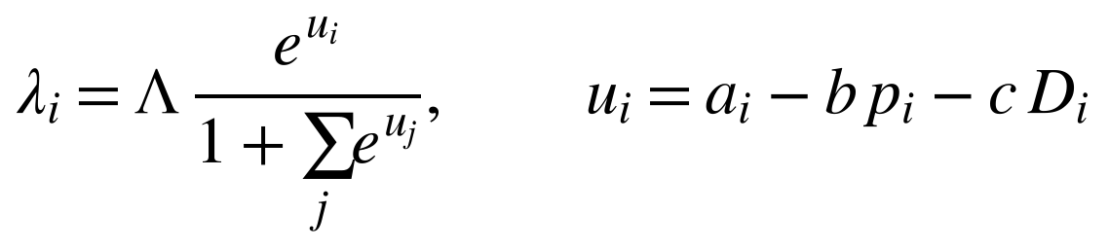
Since demand depends on delay and delay depends on demand, the two are solved together as a fixed point using a damped Newton iteration, which converges to a residual below 10⁻⁹ in every equilibrium. Platform profit per hour, with restaurant commission m = ₹45 per order, is:
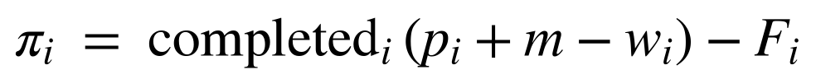
Total welfare is the sum of consumer surplus (a logit log-sum minus the social cost of congestion delay), platform profits and rider surplus. Efficiency compares each outcome with the social planner's best welfare W*, and the price of anarchy is its inverse:
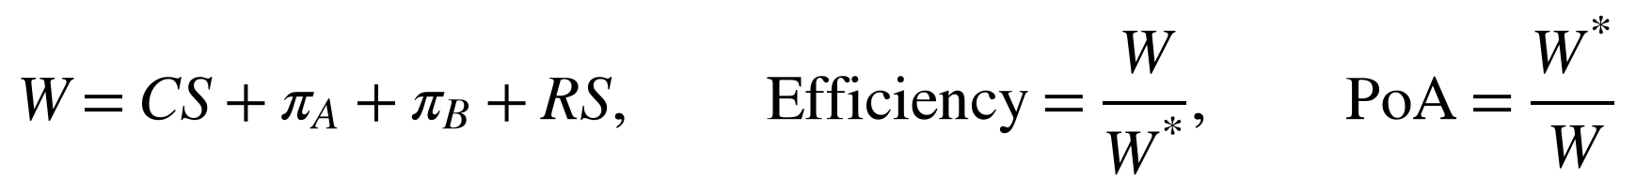
Parameter | Symbol | Default | Meaning
Rider pool | R | 500 | Multi-homing riders in the zone
Reservation incentive | w0 | ₹25 / order | Value of the riders' outside option
Rider sensitivity | β | 0.15 | Response of riders to incentive differences
Orders per rider-hour | k | 2.2 | Rider service rate
Base delay, congestion scale | d0, s | 28 min, 6 min | Delay with no congestion; growth with utilisation
Attractiveness | a | 4.0 | Customers' base preference for ordering
Fee and delay sensitivity | b, c | 0.05, 0.08 | Customer response to fee (₹) and delay (min)
Commission, fixed fee | m, p | ₹45, ₹35 | Restaurant commission; fee when not strategic
Demand scenarios | Λ | 600 / 1000 / 1500 / 2000 | Low, Medium, Peak, Extreme (orders per hour)
Table 6.1: Default parameters of the shared market environment

6.2 Simultaneous Competition: Cournot and Bertrand
A Nash equilibrium is a pair of strategies in which each platform's strategy is a best response to the other's:
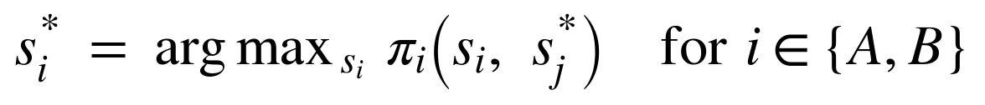
In the Cournot model the strategy is the number of riders N_{i}, and the incentive follows from the inverse supply curve. In the Bertrand incentive model the strategy is the incentive w_{i}. In the Bertrand fee model the number of riders is fixed and the strategy is the delivery fee p_{i}. Equilibria are computed by best-response iteration: each platform's best response is found by a global grid search followed by local refinement, because profit is not always concave in the platform's own strategy. The homogeneous Bertrand variant raises rider sensitivity to β = 5, so that riders almost always choose the higher payer, and illustrates the Bertrand paradox.

6.3 Sequential Competition: Stackelberg and Two-Stage Game
In the Stackelberg models Platform A commits first, to either its capacity or its incentive, and Platform B observes the commitment and best-responds. The game is solved by backward induction, and the first-mover advantage (FMA) is the leader's gain relative to the simultaneous game:
In the two-stage game both platforms first choose capacity and then, knowing the capacities, choose fees. The fee subgame is solved for every capacity pair, and the capacity stage is solved on the resulting reduced-form profits:

6.4 Strategic-Form Game
For the strategic-form analysis the incentive is reduced to three levels: Low (the collusive incentive), High (the most profitable one-shot deviation against Low) and Medium (their midpoint). The payoff matrix is filled with profits from the market environment. The system highlights best responses and pure Nash equilibria, and performs iterated elimination of strictly and weakly dominated strategies step by step. Mixed-strategy equilibria are found by support enumeration, which solves the indifference conditions:
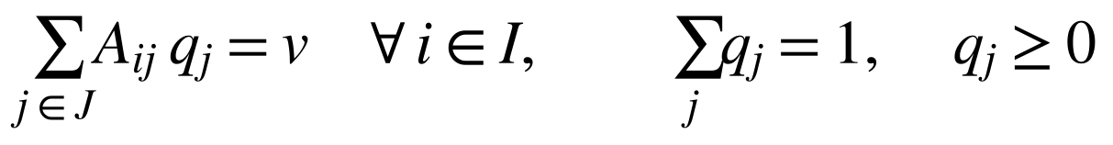
Maxmin (security) strategies are computed by linear programming. The 2 × 2 Low/High game is labelled a Prisoner's Dilemma when, for both players, the temptation, reward, punishment and sucker payoffs satisfy:
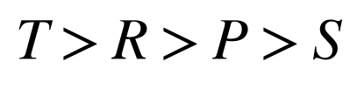

6.5 Repeated Game
The incentive game is played every day. Under a grim-trigger strategy a platform cooperates (keeps the Low incentive) until the rival defects, and then defects forever. Cooperation is sustainable when the discount factor δ is at least the critical value δ*:
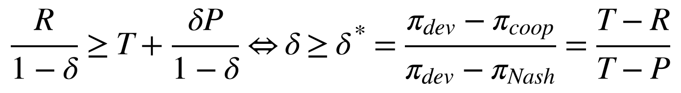
The system also simulates a round-robin tournament over T = 60 days between Always Defect, Always Cooperate, Grim Trigger, Tit-for-Tat and Generous Tit-for-Tat. Imperfect observability is modelled by a probability that a cooperative move is observed as a defection.

6.6 Bayesian Game of Incomplete Information
Each platform privately knows whether its own demand is High or Low (its attractiveness is a ± 0.3), with a prior probability of High demand. Each platform chooses a type-contingent capacity that maximises its expected profit given the rival's strategy:
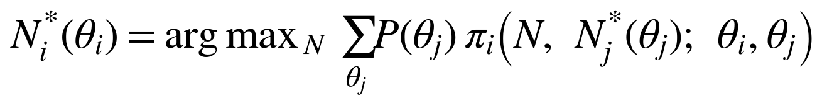
The Bayesian Nash equilibrium is computed by best-response iteration over the four type-contingent strategies and compared with the complete-information Cournot outcome for each type profile.

6.7 Agent-Based Simulation and Monte Carlo Method
The simulation represents a 20 × 20 km city with 40 restaurants in five hotspots over a three-hour peak, with a demand curve that rises, peaks and falls. Every 15 minutes each of the 500 riders chooses a platform using the equilibrium incentives. Orders are assigned to the nearest idle rider, food preparation takes about 12 minutes on average, and orders are cancelled if no rider is assigned within 20 minutes. The simulation is repeated over n = 20 random seeds and averaged:
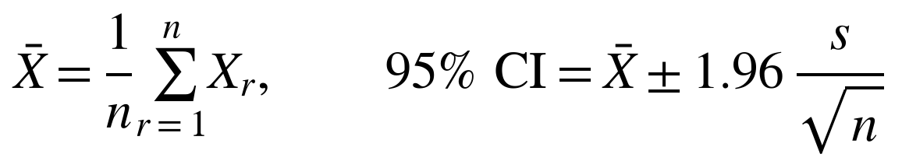
The simulated delays are compared with the analytical delay function, re-solved at each minute's arrival rate, and the mean absolute error and mean absolute percentage error are reported.

6.8 Testing and Evaluation
Every equilibrium returned by the system is verified. For each platform, profit is evaluated at 401 alternative strategies with the rival held fixed, followed by local refinement, and the equilibrium passes if no deviation gains more than the tolerance:
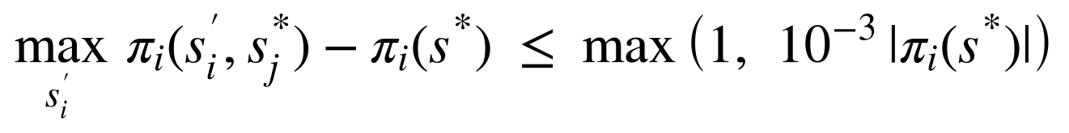
The backend is tested with 54 automated pytest tests, including textbook cases with known answers. All tests pass. Table 6.2 lists the main test cases.
S. No. | Test case | Expected result | Actual result | Status
1 | Linear Cournot, P = 100 − Q, c = 10 | q* = (a − c)/3b = 30 | 30.000 | Pass
2 | Linear Stackelberg leader output | (a − c)/2b = 45 | 45.000 | Pass
3 | Homogeneous Bertrand price | Price → marginal cost | Within one price step of cost | Pass
4 | Grim trigger δ* for PD (T, R, P, S) = (5, 3, 1, 0) | δ* = 0.5 | 0.5 | Pass
5 | Mixed NE of Matching Pennies | (0.5, 0.5) | (0.5, 0.5) | Pass
6 | Bayesian Cournot (textbook closed form) | Closed-form quantities | Match to 10⁻⁴ | Pass
7 | Demand–delay fixed point, all scenarios | Converges, residual < 10⁻⁷ | Converged in all cases | Pass
8 | Deviation check, every model and scenario | No profitable deviation | 32 of 32 verified | Pass
9 | Simulation payload and reproducibility | < 5 MB, same seed gives same result | 3.6 MB maximum, reproducible | Pass
10 | API endpoints (8 tests) | Correct responses and validation | All passed | Pass
Table 6.2: Main test cases

7. RESULTS AND DISCUSSION
All results below use the default parameters. The screenshots are taken from the running application; the additional charts are generated from the same engine.

7.1 Overview Page
The Overview page presents the problem statement, a diagram of the two-sided market linking customers, the two platforms and the shared rider pool, the reasons game theory is needed, the research questions and a five-minute tour of the application. Summary cards show that all 32 model-and-scenario equilibria are verified and quantify the cost of the incentive war at peak demand.
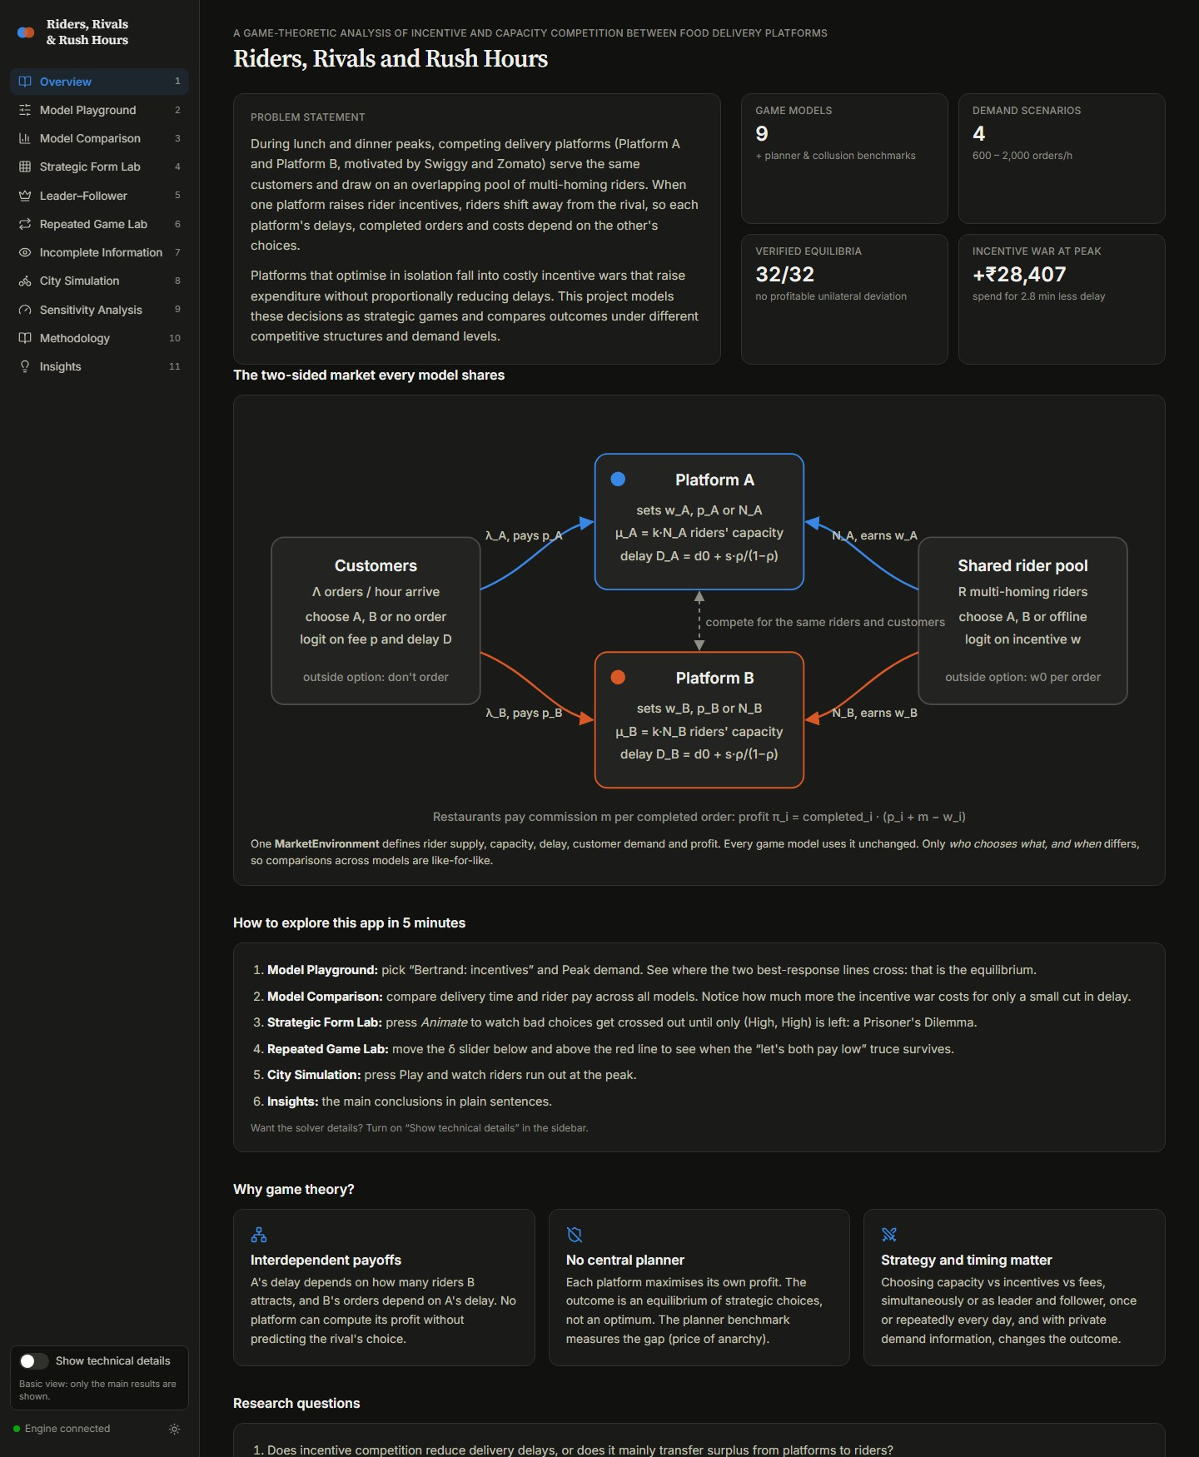
Figure 7.1: Overview page of the application

7.2 Model Playground
The Model Playground lets the user choose any model and demand scenario and change the market parameters. For Bertrand competition on incentives at Peak demand, the equilibrium incentive is ₹60.9 per order for both platforms. Each platform delivers 349 orders per hour with an average delay of 38.5 minutes, earns ₹6,659 per hour and pays ₹21,283 per hour to riders. The outcome reaches 97% of the social planner's welfare. The best-response curves cross at the Nash equilibrium, and the verification badge confirms that no platform can gain by switching alone.
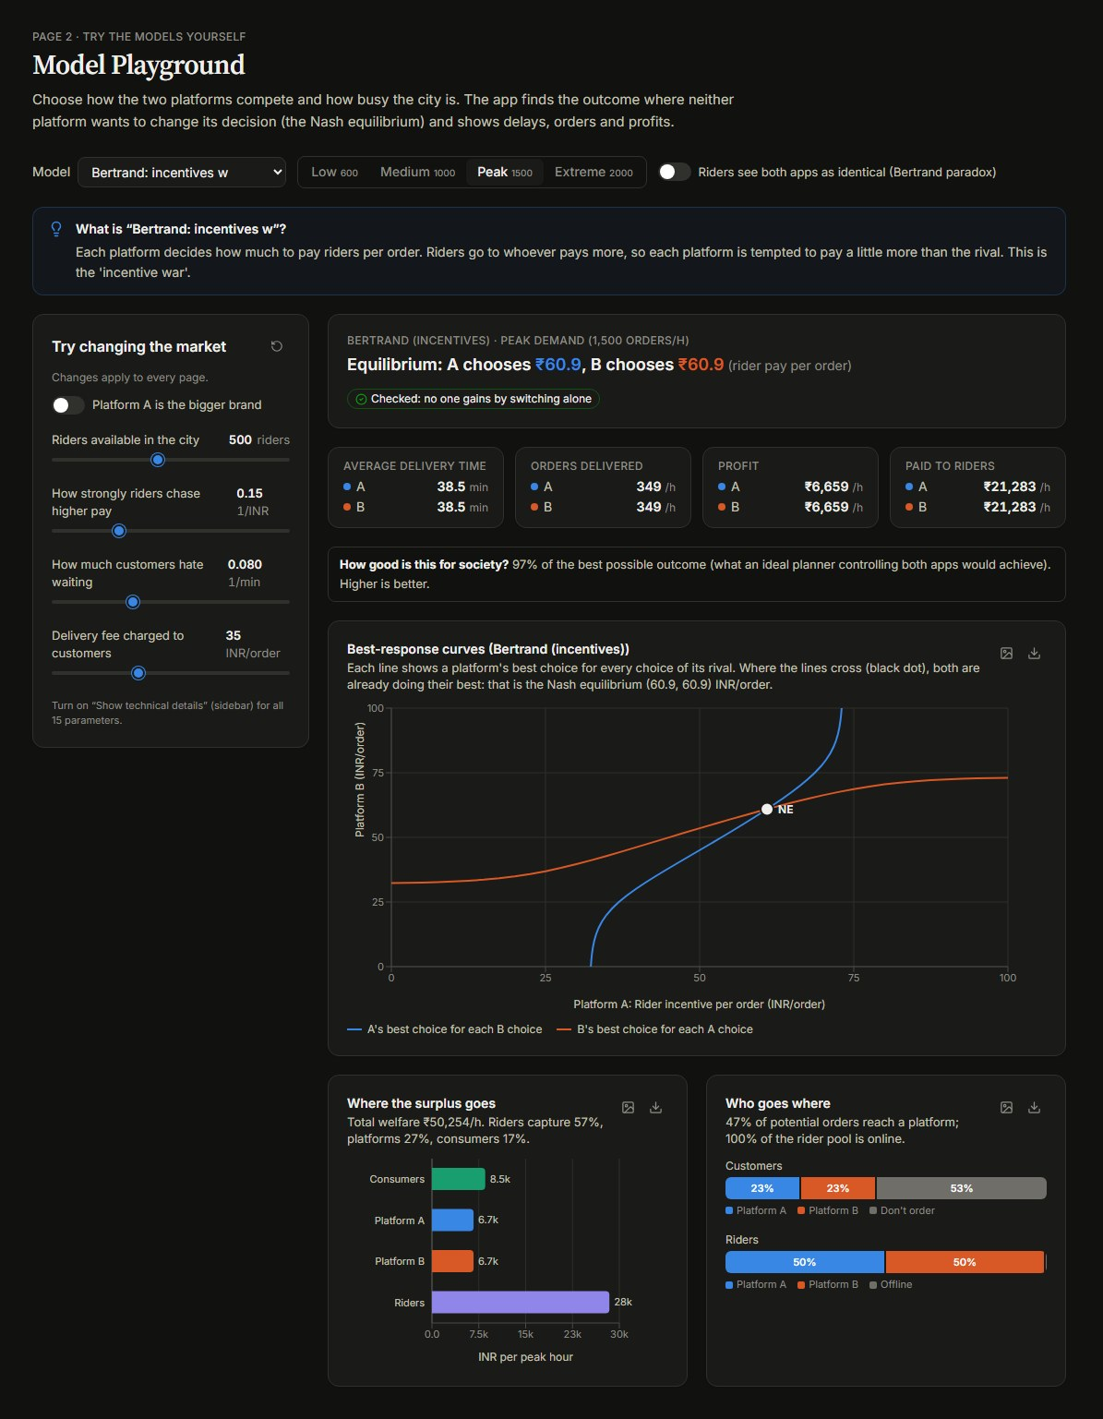
Figure 7.2: Model Playground showing the Bertrand incentive equilibrium at Peak demand

7.3 Model Comparison
The Model Comparison page compares all eight structures across the four demand scenarios. Table 7.1 summarises the results for Peak demand. Incentive (Bertrand) competition pays riders ₹42,567 per hour, almost twice the ₹21,970 paid under Cournot capacity competition, yet reduces average delay by only 1.7 minutes. Collusion yields high profit but the longest delay, and fee-based Bertrand competition delivers the fewest orders.
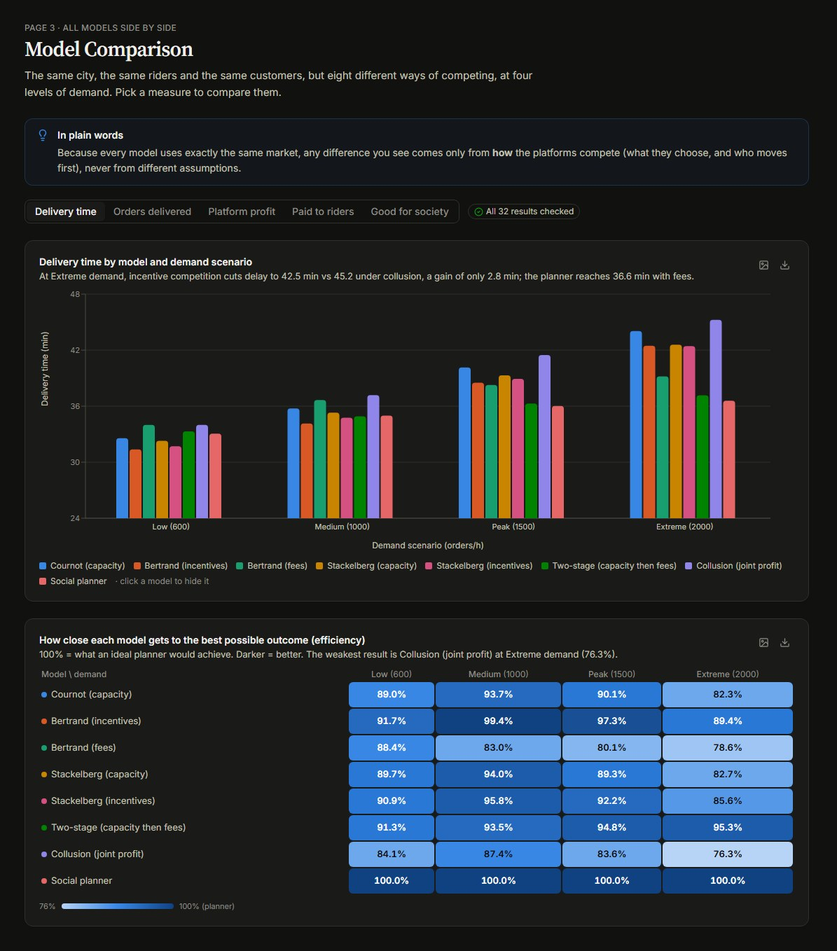
Figure 7.3: Model Comparison page with grouped bar chart and efficiency heatmap
Model | Strategy (A / B) | Delay (min) | Orders / h | Profit (₹/h) | Rider pay (₹/h) | Efficiency
Cournot (capacity) | N = 220.6 / 220.6 | 40.2 | 650 | 30,011 | 21,970 | 90.1%
Bertrand (incentives) | w = 60.9 / 60.9 | 38.5 | 699 | 13,318 | 42,567 | 97.3%
Bertrand (fees) | p = 48.8 / 48.8 | 38.3 | 463 | 31,831 | 11,574 | 80.1%
Stackelberg (capacity) | N = 349.0 / 123.9 | 39.3 | 649 | 26,043 | 25,858 | 89.3%
Stackelberg (incentives) | w = 42.0 / 47.8 | 38.9 | 668 | 22,871 | 30,576 | 92.2%
Two-stage (capacity, fees) | N = 221.1 / 221.1 | 36.3 | 564 | 32,152 | 19,149 | 94.8%
Collusion (joint profit) | w = 29.8 / 29.8 | 41.5 | 611 | 30,711 | 18,189 | 83.6%
Social planner | w = 68.0 / 68.0 | 36.0 | 629 | 12,417 | 42,754 | 100.0%
Table 7.1: Comparison of all models at Peak demand (Λ = 1,500 orders/h)
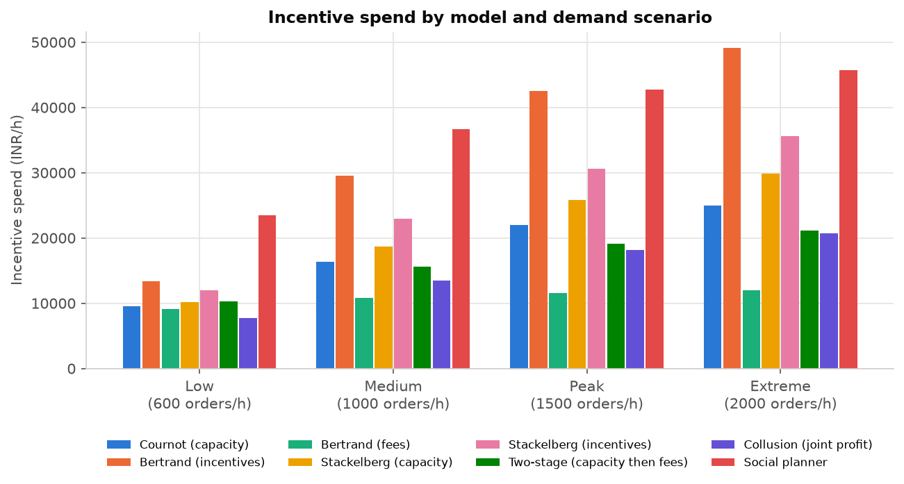
Figure 7.4: Incentive spending by model and demand scenario

7.4 Strategic Form Lab
At Peak demand the Low incentive (collusive level) is ₹29.8 and the High incentive (best deviation) is ₹39.5. Iterated elimination of strictly dominated strategies removes Low and then Medium for both platforms, leaving the unique Nash equilibrium (High, High) with a profit of ₹13,729 each. Both platforms would earn ₹15,356 at (Low, Low). The 2 × 2 Low/High game satisfies T > R > P > S (₹18,964 > ₹15,356 > ₹13,729 > ₹7,517) and is labelled a Prisoner's Dilemma in all four demand scenarios. The page also includes textbook games such as Matching Pennies, whose mixed equilibrium (0.5, 0.5) is computed by support enumeration.

Figure 7.5: Strategic Form Lab: payoff matrix, Nash equilibrium and dominance elimination

7.5 Leader–Follower Games
When Platform A commits first to capacity at Peak demand, it hires 349 riders while Platform B hires only 124. A's profit rises from ₹15,005 to ₹16,876 (a first-mover advantage of ₹1,870 per hour), while B's profit falls by ₹5,838. Capacities are strategic substitutes, so committing to a large fleet discourages the rival. When A instead commits to an incentive, it chooses a moderate ₹42.0 and B responds with ₹47.8. A still gains ₹2,124, but B gains even more (₹7,429), a second-mover advantage that arises because incentives are strategic complements. In the two-stage game, equilibrium capacities are within 0.7% of the Cournot capacities in every scenario, which illustrates the Kreps–Scheinkman result.
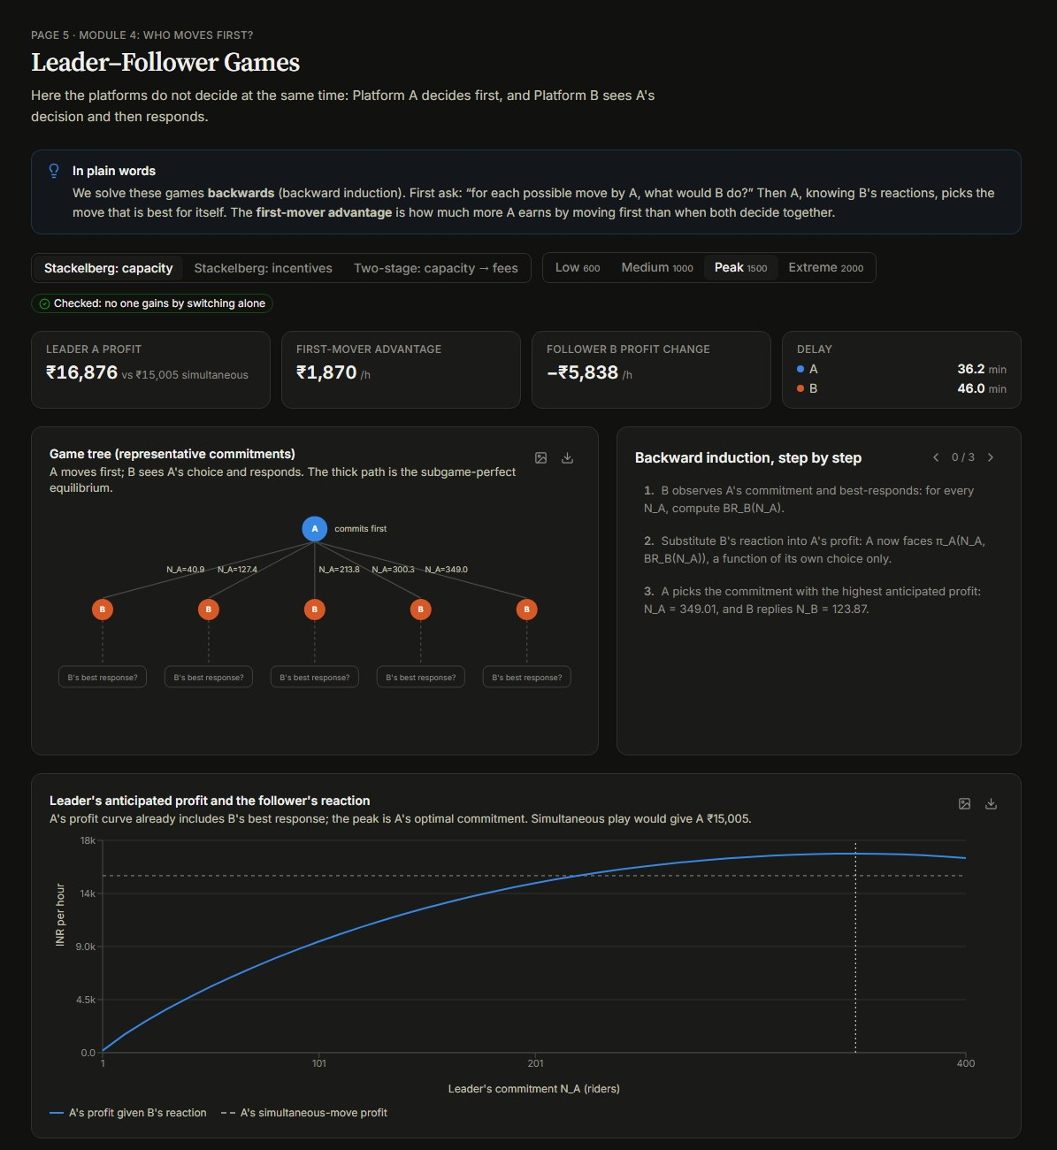
Figure 7.6: Leader–Follower page with game tree and backward induction
Demand | FMA (capacity) | FMA (incentive) | Follower gain (incentive) | Two-stage N | Cournot N
Low | ₹73 | ₹292 | ₹788 | 183.7 | 183.9
Medium | ₹599 | ₹1,460 | ₹3,825 | 210.4 | 209.9
Peak | ₹1,870 | ₹2,124 | ₹7,429 | 221.1 | 220.6
Extreme | ₹2,908 | ₹2,149 | ₹8,955 | 225.7 | 224.2
Table 7.2: First-mover advantage and two-stage capacities

7.6 Repeated Game Lab
The critical discount factor for grim-trigger cooperation is 0.506 at Low demand, 0.627 at Medium, 0.689 at Peak and 0.710 at Extreme demand. Cooperation is therefore hardest to sustain exactly when demand is highest, because the one-time gain from stealing riders is largest at peak. If the punishment is reversion to the one-shot Bertrand equilibrium, the threshold falls to about 0.3. With a discount factor of 0.9 cooperation is sustainable in all scenarios. In the tournament, Always Defect scores highest overall at Medium demand and above because it exploits Always Cooperate, while Grim Trigger and Tit-for-Tat sustain full cooperation with each other. With 5% observation noise at Medium demand, Grim Trigger cooperates on only 19% of days, while Generous Tit-for-Tat keeps cooperation on 80% of days.
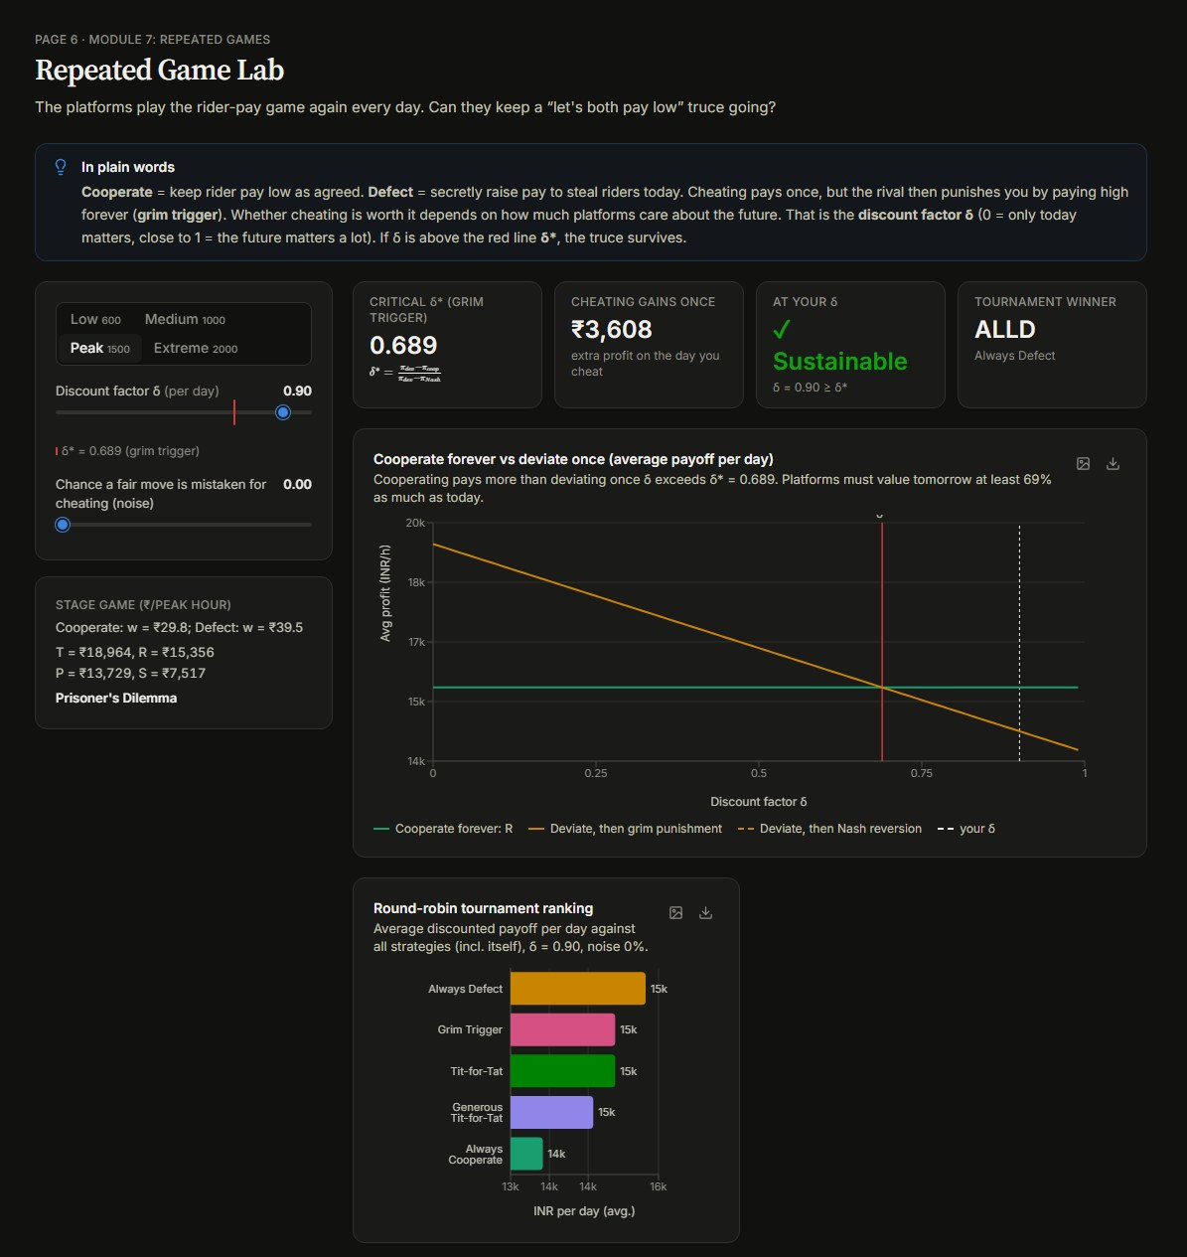
Figure 7.7: Repeated Game Lab with critical discount factor and strategy tournament
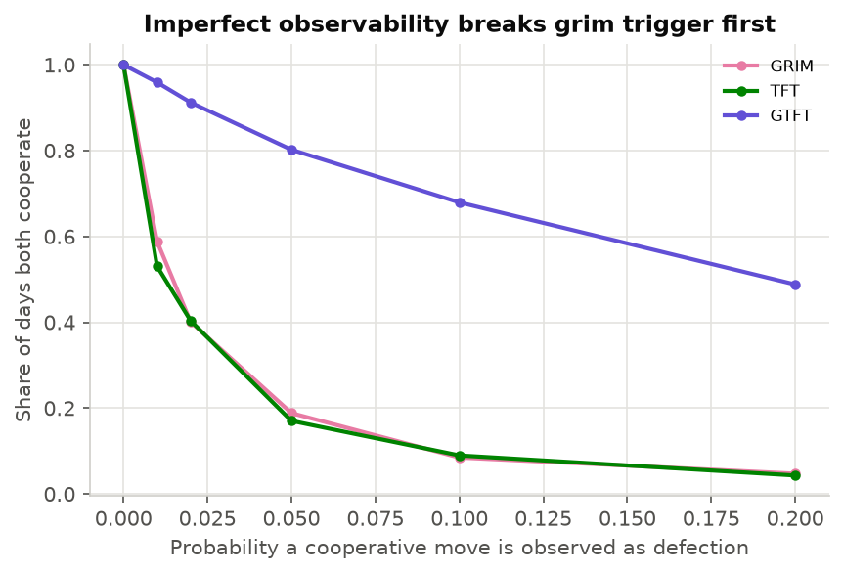
Figure 7.8: Cooperation rate under imperfect observability

7.7 Incomplete Information
With a prior probability of 0.5 that demand is High, each platform hires more riders when its own demand is High. Because a platform cannot see the rival's demand, it responds to the rival's average behaviour, so the High and Low types choose capacities closer to each other than under complete information. All type-contingent strategies pass the deviation check.
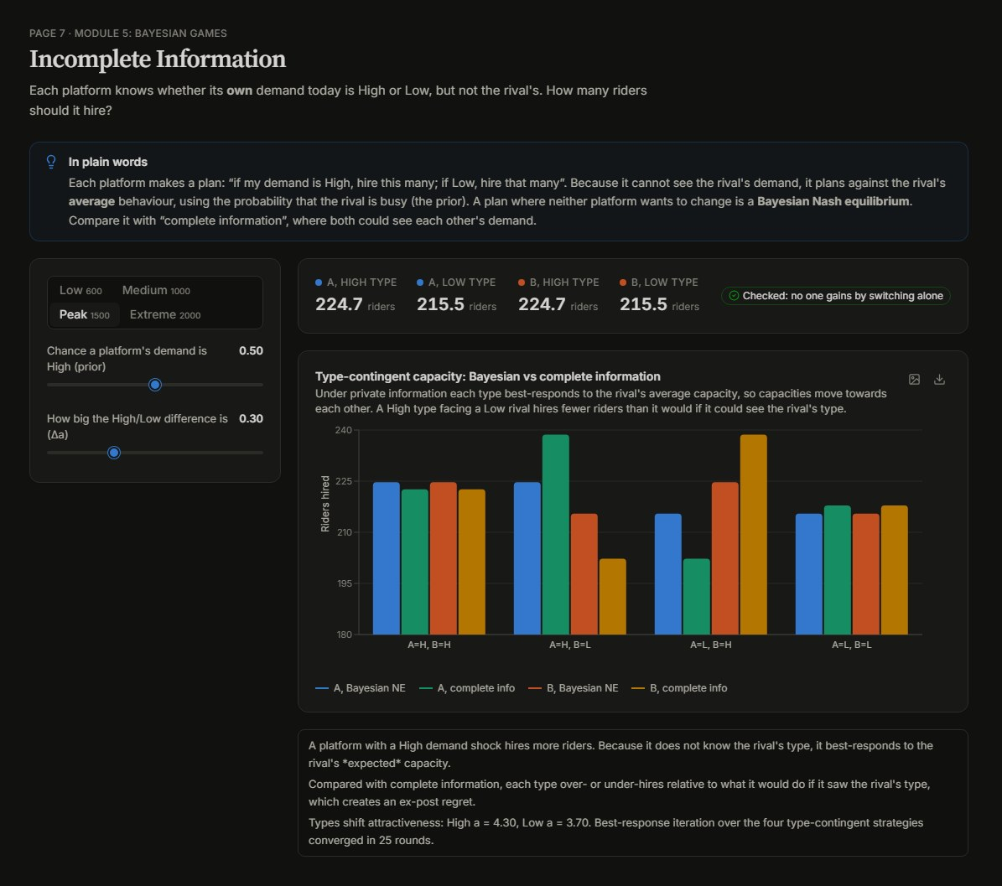
Figure 7.9: Incomplete Information page: Bayesian Nash equilibrium capacities

7.8 City Simulation and Validation
The City Simulation page animates riders and orders over the three-hour peak, with live charts of delay, idle riders and waiting orders. At Peak demand the idle-rider buffer falls to zero in the middle of the peak and queues of waiting orders form. Across 10 seeds per scenario, the simulated mean delay at Peak demand is 36.9 minutes (95% CI 36.5–37.2) compared with 39.2 minutes predicted by the analytical model, and at Extreme demand 40.4 minutes compared with 43.0. The overall per-minute mean absolute percentage error is 17%. The analytical delay function is close at peak and conservative at moderate demand, because a large fleet of riders shows little queueing until utilisation approaches one.
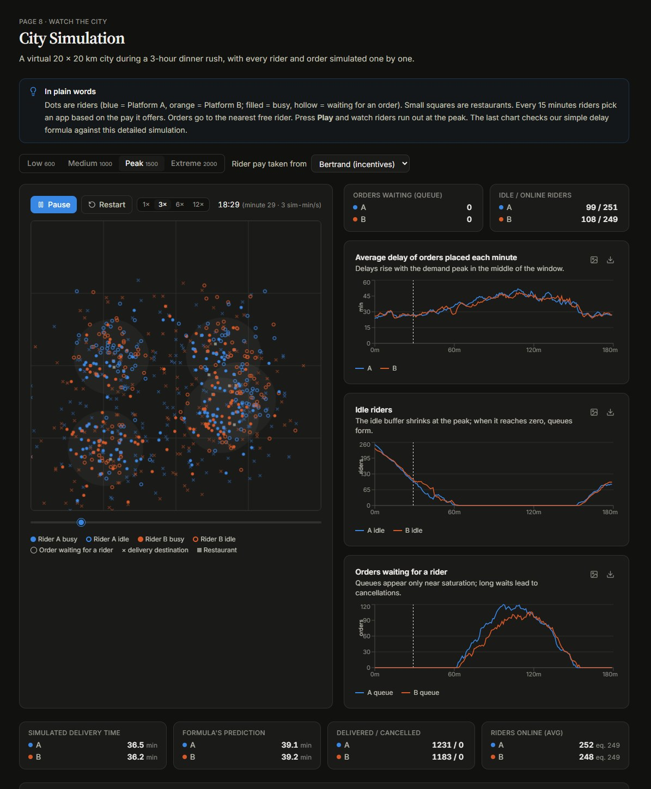
Figure 7.10: City Simulation page with animated city map and live metrics
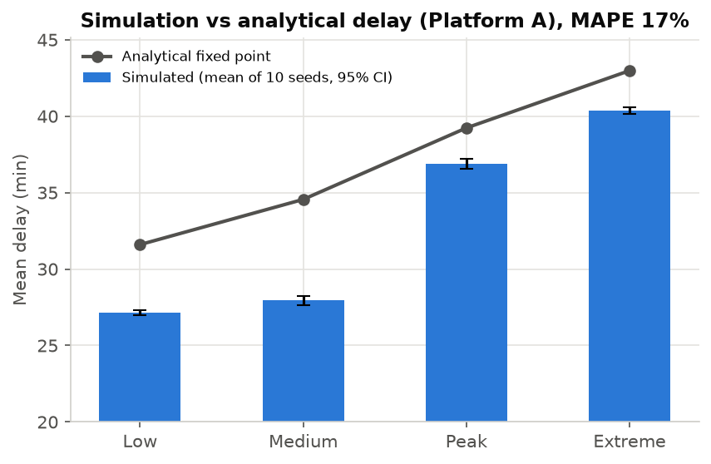
Figure 7.11: Simulated versus analytical delay by demand scenario

7.9 Sensitivity Analysis
The Sensitivity Analysis page varies one parameter at a time, such as rider sensitivity β, delay sensitivity c, rider speed k, rider pool R or demand Λ, and re-solves every selected model. For example, at Peak demand, as β increases from 0.05 to 0.40 riders switch platforms more readily: average delay under incentive competition falls from 41.8 to 38.5 minutes, and the efficiency gap between collusion and incentive competition narrows (collusion rises from 76% to 91% efficiency, incentive competition from 92% to 97%).
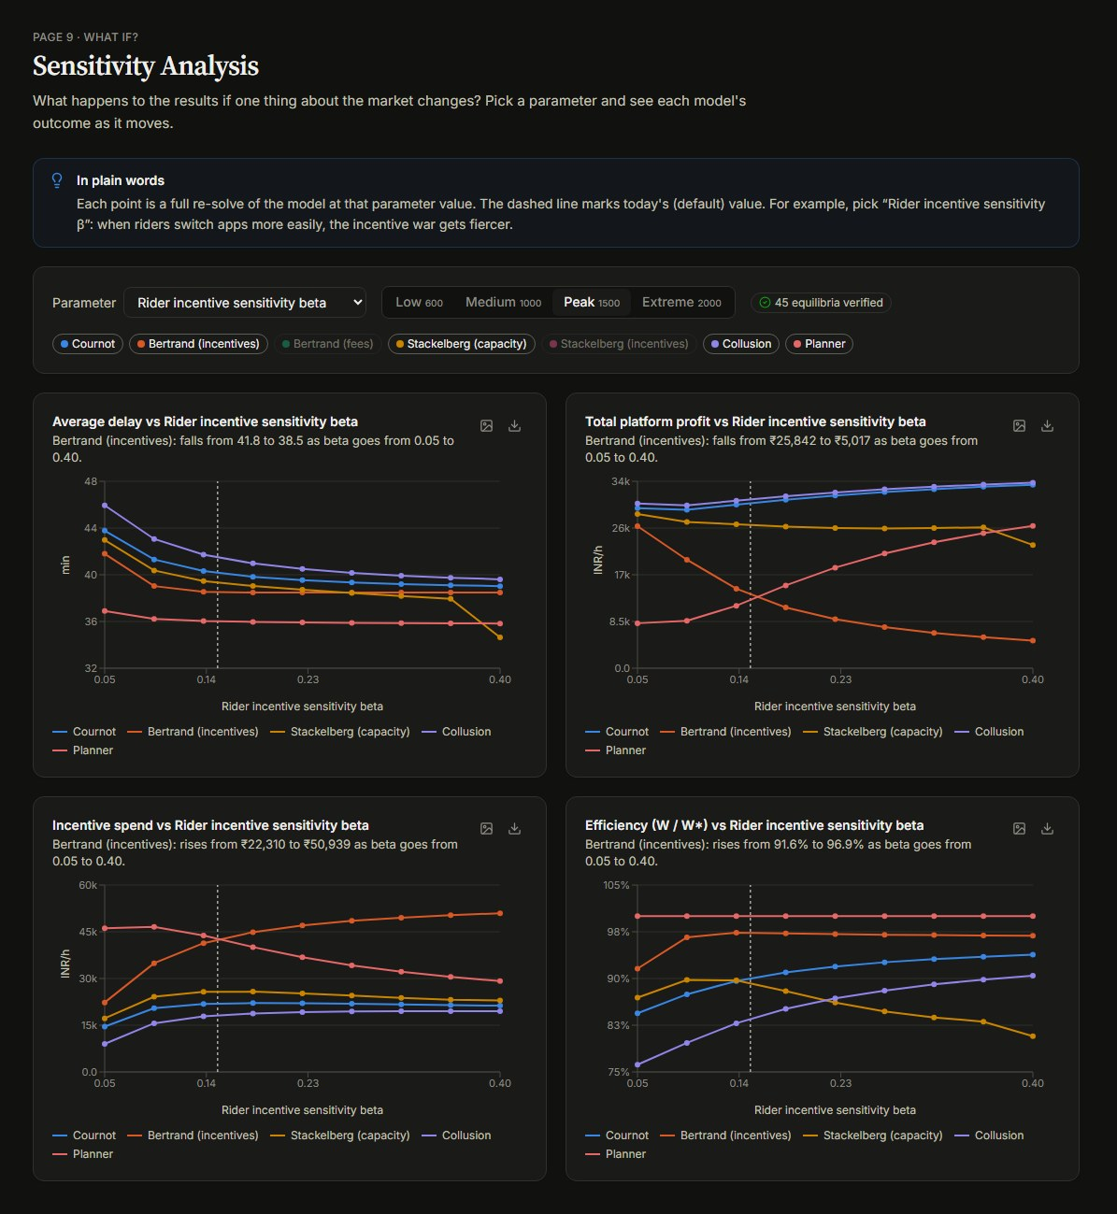
Figure 7.12: Sensitivity Analysis page

7.10 Insights and Overall Discussion
The Insights page generates the key findings automatically from the solved models (Figure 7.13). Taken together, the results show that:
- Incentive wars mainly transfer surplus to riders. At Extreme demand, incentive competition raises incentive spending by about ₹28,400 per hour compared with collusion, but reduces delay by only 2.8 minutes; about 84% of the extra spending becomes rider surplus.
- Committing to capacity first helps the leader, and more so as demand rises; committing to an incentive first helps the follower even more.
- The low-incentive truce is hardest to sustain at peak demand (δ* rises from 0.51 to 0.71), and noisy observation quickly breaks grim-trigger cooperation.
- Capacity precommitment reproduces Cournot capacities, and the resulting fee competition acts as congestion pricing.
- Collusion is among the least efficient outcomes in every scenario, while incentive competition comes closest to the social optimum at Low to Peak demand.
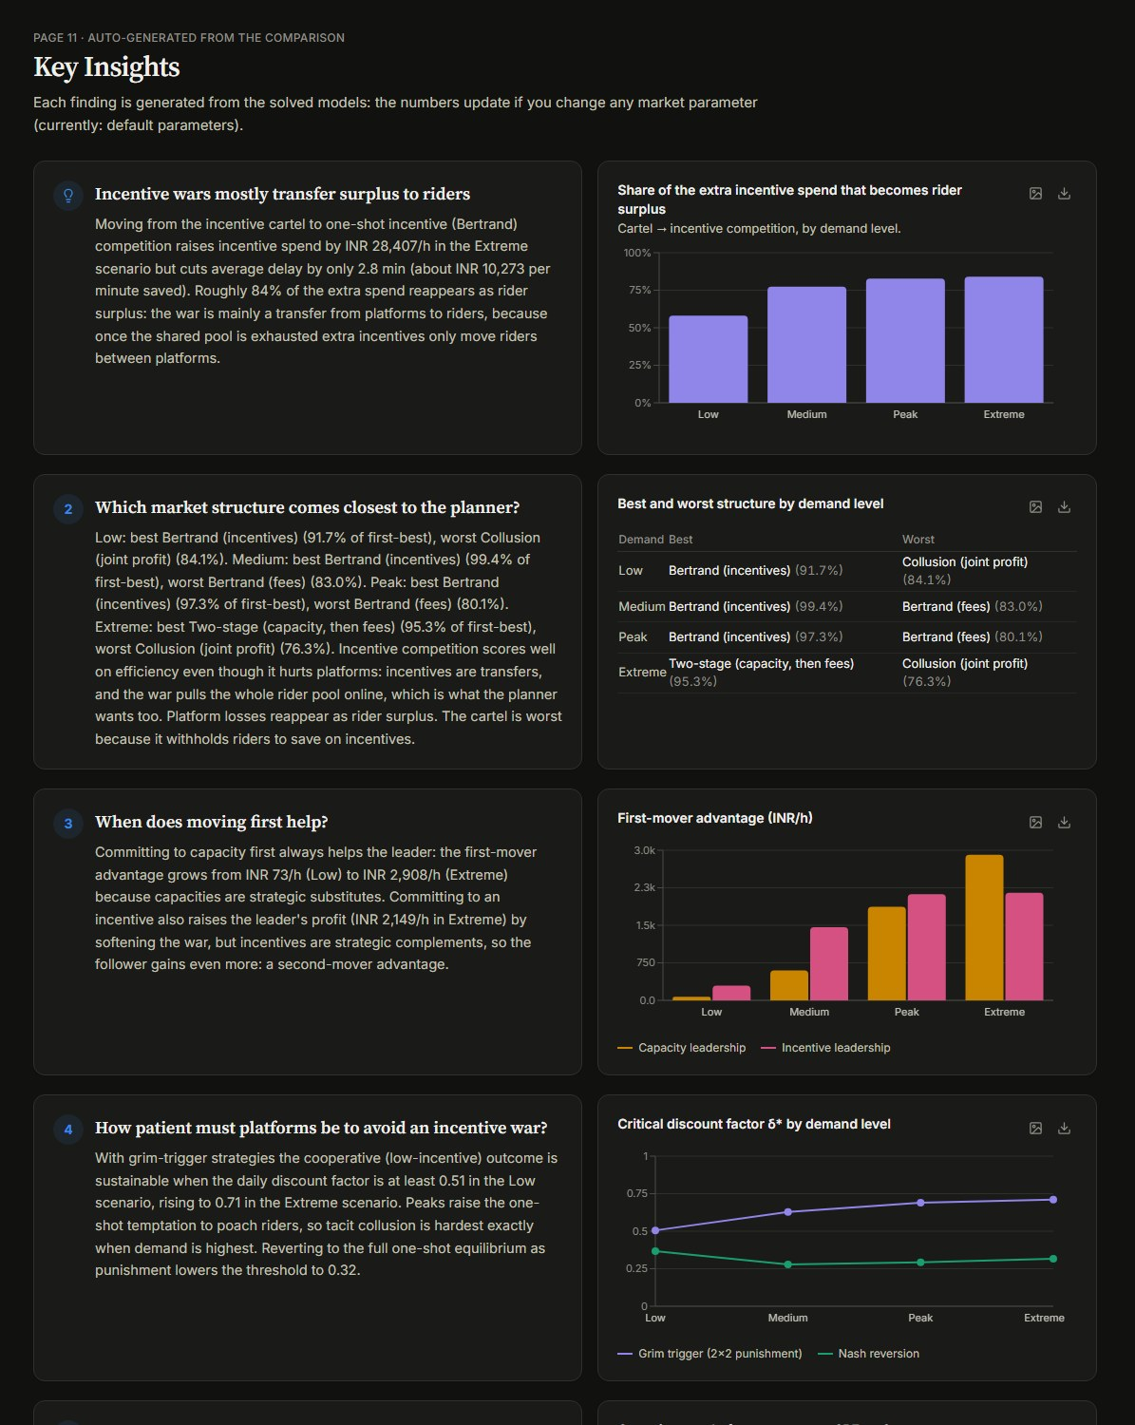
Figure 7.13: Insights page with auto-generated findings

8. CONCLUSION
Riders, Rivals and Rush Hours provides an integrated game-theoretic analysis of incentive and capacity competition between two food-delivery platforms. The project combines a shared market environment with nine competitive structures: Cournot, Bertrand on incentives and fees, the homogeneous Bertrand paradox, Stackelberg leadership, a two-stage capacity-then-fee game, a strategic-form game, a repeated game and a Bayesian game, together with social-planner and collusion benchmarks. Because every model uses exactly the same environment, the comparison of outcomes is consistent.
The application is developed using React and Vite for the frontend and FastAPI with Python for the backend. Its eleven pages allow users to explore equilibria, best-response curves, payoff matrices, game trees, repeated-game strategies, Bayesian strategies, an animated city simulation and sensitivity analyses, and to export charts and tables. Every equilibrium is verified numerically, and the backend passes all 54 automated tests, including textbook cases with known solutions.
The analysis shows that incentive wars mainly transfer surplus from platforms to riders rather than reducing delays, that moving first helps when committing to capacity but favours the follower when committing to incentives, and that tacit cooperation between platforms is hardest to sustain at peak demand. Capacity precommitment reproduces Cournot outcomes, consistent with the Kreps–Scheinkman result. The agent-based simulation confirms that the analytical delay function is reasonably accurate at peak demand, with an average error of about 17%.
The project has limitations. It models one city zone and one peak hour, uses illustrative rather than estimated parameters, and uses a simple single-queue delay formula. Riders respond only to the incentive per order, and the repeated game uses two actions per day. Future work could estimate parameters from real platform data, model several zones and time periods, add rider learning and dynamic surge pricing, include restaurants as a third side of the market, and extend the repeated game to richer punishment strategies.
In conclusion, the project demonstrates how core concepts of game theory, namely Nash equilibrium, dominance, mixed strategies, backward induction, repeated games and Bayesian games, can be combined in one consistent, verifiable and interactive analysis of a real platform market.

9. REFERENCES
[1] Cournot, A. A. (1838). Recherches sur les principes mathématiques de la théorie des richesses. Paris: Hachette.
[2] Bertrand, J. (1883). Review of Théorie mathématique de la richesse sociale and Recherches sur les principes mathématiques de la théorie des richesses. Journal des Savants, 67, 499–508.
[3] von Stackelberg, H. (1934). Marktform und Gleichgewicht. Vienna: Springer.
[4] Nash, J. F. (1950). Equilibrium points in n-person games. Proceedings of the National Academy of Sciences, 36(1), 48–49.
[5] Kreps, D. M., and Scheinkman, J. A. (1983). Quantity precommitment and Bertrand competition yield Cournot outcomes. The Bell Journal of Economics, 14(2), 326–337.
[6] Friedman, J. W. (1971). A non-cooperative equilibrium for supergames. The Review of Economic Studies, 38(1), 1–12.
[7] Axelrod, R. (1984). The Evolution of Cooperation. New York: Basic Books.
[8] Nowak, M. A., and Sigmund, K. (1992). Tit for tat in heterogeneous populations. Nature, 355, 250–253.
[9] Harsanyi, J. C. (1967). Games with incomplete information played by "Bayesian" players, Part I. Management Science, 14(3), 159–182.
[10] Rochet, J.-C., and Tirole, J. (2003). Platform competition in two-sided markets. Journal of the European Economic Association, 1(4), 990–1029.
[11] Armstrong, M. (2006). Competition in two-sided markets. The RAND Journal of Economics, 37(3), 668–691.
[12] Cachon, G. P., Daniels, K. M., and Lobel, R. (2017). The role of surge pricing on a service platform with self-scheduling capacity. Manufacturing & Service Operations Management, 19(3), 368–384.
[13] Taylor, T. A. (2018). On-demand service platforms. Manufacturing & Service Operations Management, 20(4), 704–720.
[14] Bai, J., So, K. C., Tang, C. S., Chen, X., and Wang, H. (2019). Coordinating supply and demand on an on-demand service platform with impatient customers. Manufacturing & Service Operations Management, 21(3), 556–570.
[15] Bernstein, F., DeCroix, G. A., and Keskin, N. B. (2021). Competition between two-sided platforms under demand and supply congestion effects. Manufacturing & Service Operations Management, 23(5), 1043–1061.
[16] McFadden, D. (1974). Conditional logit analysis of qualitative choice behavior. In P. Zarembka (Ed.), Frontiers in Econometrics (pp. 105–142). New York: Academic Press.
[17] Koutsoupias, E., and Papadimitriou, C. (1999). Worst-case equilibria. In STACS 99, Lecture Notes in Computer Science, 1563, 404–413.
[18] Osborne, M. J., and Rubinstein, A. (1994). A Course in Game Theory. Cambridge, Massachusetts: MIT Press.
[19] Gibbons, R. (1992). Game Theory for Applied Economists. Princeton: Princeton University Press.
[20] React Team. React Documentation. Available at: https://react.dev/
[21] FastAPI. FastAPI Documentation. Available at: https://fastapi.tiangolo.com/
[22] Vite Team. Vite Documentation. Available at: https://vite.dev/
[23] NumPy and SciPy Developers. NumPy and SciPy Documentation. Available at: https://numpy.org/doc/ and https://docs.scipy.org/doc/scipy/

10. IMPLEMENTATION VIDEO LINK
YouTube Link:
Google Link:
Project (GitHub Link):

